Dataset

The instructions to download the data are provided below.

Data I-A download:

* Go to the URL:<https://data.gov.in/> and search for the keyword 'State-wise Gross Domestic Product (GDP) at current price on yearly basis'.
* Select the 'State-wise Gross Domestic Product (GDP) at current price on yearly basis' from the search result and download the data. (Alternatively, if you are not able to search for the dataset with the keywords, you can download the dataset from [this link](https://data.gov.in/resources/state-wise-gross-domestic-product-gdp-current-price-yearly-basis).)
* If you face any problem while downloading, you can click on "View Visualization".

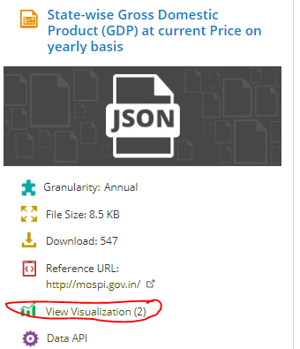

* You can download the data from there. There are various interesting visualizations to choose from.

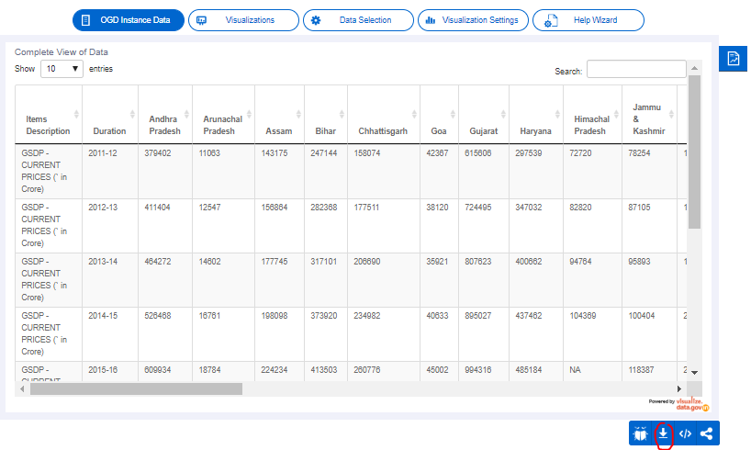

Data I-B download:

The dataset that you will download will contain data on the Gross State Value Added (GSVA) and the Gross State Domestic Product (GSDP). The GSVA at basic prices plus taxes on products less the subsidies on products will give the GSDP at market prices.

* Go to the URL: <https://data.gov.in/> and search for the keyword 'GSVA by Economic Activity at Current Prices'.
* Click on "More Similar Results".

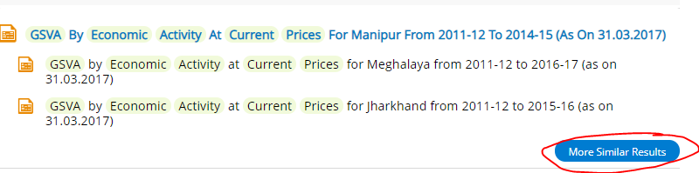

* Here, you can find Gross State Value Added (GSVA) for all the states. Download the data for all the states, not the union territories.

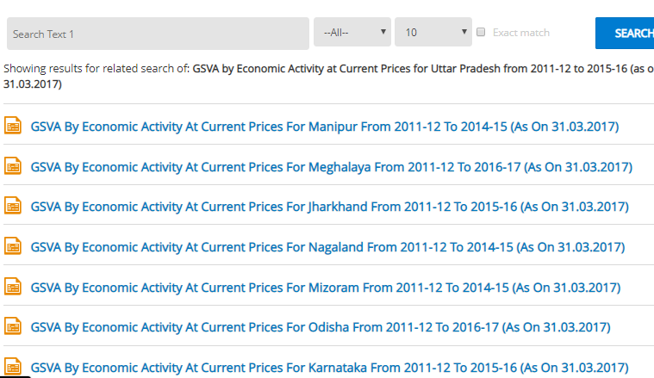

Data II download:

Download the dropout rates data from the link below:

<https://data.gov.in/resources/state-ut-wise-average-annual-drop-out-rate-2012-13-2014-15-ministry-human-resource>